Fading

This example demonstrates the use of analog output ([Pulse Width Modulation (PWM)](https://www.arduino.cc/en/Tutorial/PWM)) to fade an LED. PWM is a technique for getting an analog-like behavior from a digital output by switching it off and on very fast and with different ratio between on and off time.

Hardware Required

* Arduino or Genuino board
* LED
* 220 ohm resistor
* hook-up wires
* breadboard

Circuit

An LED connected to digital output pin 9 through a 220 ohm resistor.

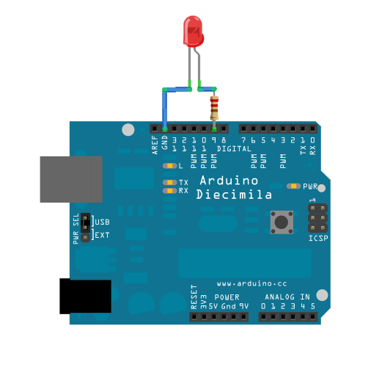

Schematic

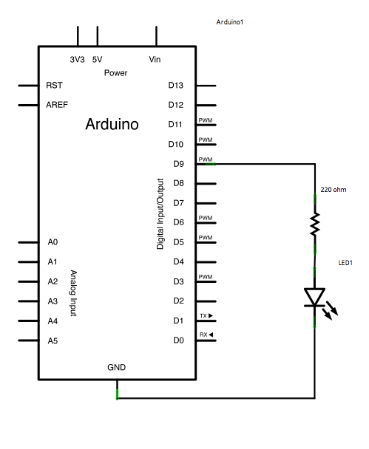

Code

In this example two loops are executed one after the other to increase and then decrease the value of the output on pin 9.

int ledPin = 9;    *// LED connected to digital pin 9*  
  
void **setup**() {  
  *// nothing happens in setup*  
}

void **loop**() {  
  *// fade in from min to max in increments of 5 points:*  
  for (int fadeValue = 0 ; fadeValue <= 255; fadeValue += 5) {  
    *// sets the value (range from 0 to 255):*  
    analogWrite(ledPin, fadeValue);  
    *// wait for 30 milliseconds to see the dimming effect*  
    delay(30);  
  }  
  
  *// fade out from max to min in increments of 5 points:*  
  for (int fadeValue = 255 ; fadeValue >= 0; fadeValue -= 5) {  
    *// sets the value (range from 0 to 255):*  
    analogWrite(ledPin, fadeValue);  
    *// wait for 30 milliseconds to see the dimming effect*  
    delay(30);  
  }  
}